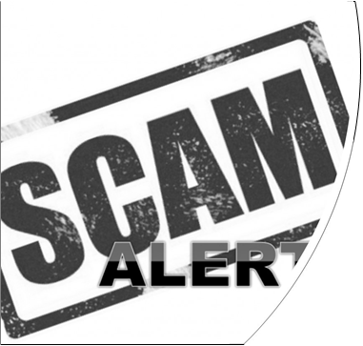

Is it Safe or Is It a Scam?
1

John’s email
John gets a text message from USAA that says his account is locked. It tells him to click on a link for more information. Is it safe or is it a scam? What should he do?
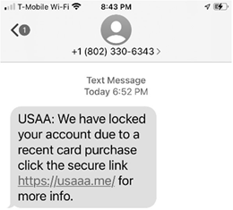
2

Cati’s text message
Cati gets a text message from Amazon that says she has a refund. The message says she needs to reply with her bank account and routing number. Is it safe or is it a scam? What should she do?
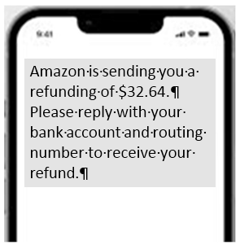
3

Martha’s email
Martha gets an email on her phone from Target that tells her she can answer to win a new Ninja coffeepot. Is it safe or is it a scam? What should she do?
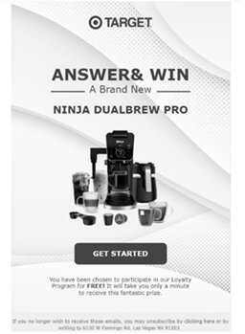
4

Tony’s pop-up window
Tony is on a web page when a pop-up window says that his computer is infected. Is it safe or is it a scam?
What should he do?
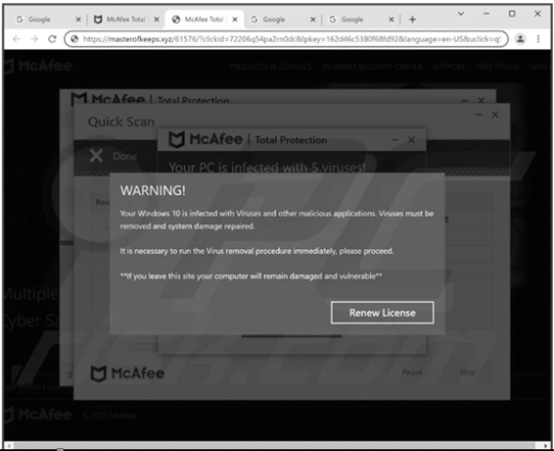
5

David’s email
David gets an email on his computer from the United States Postal Service. It asks him to click on a link to schedule a delivery. Is it safe or is it a scam?
What should he do?
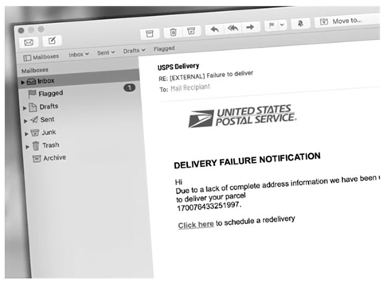
6

David’s email
Mark gets an email that he needs to confirm his gift immediately. The email looks like it is from Walmart. Is it safe or is it a scam? What should he do?
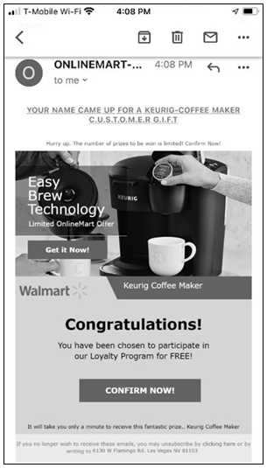
7

Sarah’s text message
Sarah gets a text message from Amazon about her account getting locked.
The message asks her to click on a link. Is it safe or is it a scam? What should she do?
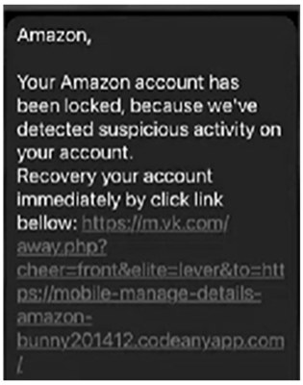
8

Barbara’s pop-up window
Barbara is on a web page. She gets a pop-up window telling her that she is a winner. Is this safe or is it a scam?
What should she do?
